

Autonomous College Permanently Affiliated to VTU, Approved by AICTE & UGC Accredited by NAAC with ‘A’ Grade, Accredited by NBA

**STRESS METER**

**A MINI PROJECT REPORT**

*Submitted by:*

**BHAVANA YC – 1NH18EE708**

**BINDHU V – 1NH18EE709**

**VARUN SHAM KUMAR – 1NH18EE753**

***In partial fulfilment for the award of the degree of***

**Bachelors of Engineering (BE)**

**In**

Electrical & Electronics



**DEPARTMENT OF ELECTRICAL AND ELECTRONICS ENGINEERING**

**CERTIFICATE**

Certified that the Mini Project work entitled **“STRESS METER”** carried out by **Bhavana YC(1NH18EE708), Bindhu V(1NH18EE709), Varun Sham Kumar(1NH18EE753)** arebonafide students of New Horizon College of Engineering submitted the report in completion of project at Department of Electrical and Electronics Engineering, New Horizon College of Engineering during the Academic Year 2019-20.

It is certified that all the corrections/suggestions indicated for Internal Assessment have been incorporated in the report deposited in the departmental library. The project report has been approved as it satisfies the academic requirements in respect of Project work prescribed for said Degree.

**Project Guide HoD-EEE**

**Mr. Muni Prakash T Dr. RamKumar S**

ACKNOWLEDGMENT

We would like to thank everyone who supported us during this entire period of making of this project. It would not have been possible without the kind support and help of many individuals and professors. We would like to extend our sincere gratitude to every one of them. In performing this mini project, we had to take the help and guideline of some respected persons, who deserve our greatest gratitude. The completion of this project gives us much pleasure and satisfaction. We would like to show our gratitude to **Mr. Muni Prakash T, Professor Dept. of Electrical Engineering** for giving us a good guideline and helping for project throughout numerous consultations. We would also like to thank **Dr. Ramkumar S, Head of the Dept. of Electrical Engineering** for helping us**.**

I am thankful to other professors also for the valuable information provided by them in their respective fields. I am grateful for their cooperation during the period of our mini project. We would also like to expand our deepest gratitude to all those who have directly and indirectly guided us in preparing this report for this mini project.

Many people, especially our own classmates and team members itself, have made valuable comment suggestions on this proposal which gave us an inspiration and hope to improve and complete the mini project. We were very excited in doing this. We thank all the people for their help directly and indirectly to complete our project successfully.

CONTENTS:

1. Aim and Objective of the project

2. Abstract

3. Introduction

4. Components required

5. Construction

6. Working

7. Merits, Demerits and Applications

8. Summary

9. Future scope of the project

10. Summary

11. References

1) AIM AND OBJECTIVE OF THE PROJECT:

To detect the stress level of the human body by considering the resistance of the body

With the help of touch pads the stress meter lets us access our emotional pain that is the resistance of the body is measured and then the stress of the human body is detected, if the stress is high then it gives us a visual indication using a light emitting diode (LED) along with a warning beep using the piezo buzzer. When stress is high - red LED glows, when the stress is moderate – yellow LED glows and when stress is low – the green LED glows, according to which the stress can be controlled. The more we learn about stress, the more we realize that monitoring stress and taking steps to keep it under control is an important preventive health measure. So this stress meter is to solve all the problems caused due to stress by checking the stress of an individual and taking care before any serious problem occurs.

2. ABSTRACT:

The overall goal of this project is to detect the stress level in the human body, it helps to access our emotional pain. Depending on the stress levels of our body the device gives us a visual indication through a light emitting diode, along with a warning beep.

The stress meter is a device which lets us know if the stress level of our body is on a controlled level or not. The property of the skin that is the stress is measured based on the resistivity of the body and is used here to detect the stress levels. The touch pads across the device detect even minute variations of the voltage across them and convey them to the circuit. The circuit then detects the stress in the body and that is indicated by the light emitting diodes.

3. INTRODUCTION:

Stress is basically a physiological state of the human body where the body gets excited to face an emergency situation or a stressful situation. The manifestations of stress cause more anxiety and stress also causes cortical levels to increase within the body, which increases the production of oil which causes acne breakouts. Stress is the body’s way of protecting us. When we are working properly it helps us stay energetic, focused and alert. It can save our lives by giving us extra strength to defend ourselves from all the tension we have. But beyond a point, the stress stops being helpful and starts causing a major damage to our health, mood, productivity and quality of life. Over stress leads to many harmful diseases which can cause death.

The stress meter is a device which lets us know if the stress level of our body is on a controlled level or not. The property of the skin that is the stress is measured based on the resistivity of the body and is used here to detect the stress levels. The touch pads across the device detect even minute variations of the voltage across them and convey them to the circuit. The circuit then detects the stress in the body and that is indicated by the light emitting diodes.

When the stress is high the resistance of the body will be low but when the stress is low the resistance of the body will be high. The stress allows us to assess the emotional pain. The circuit is based on the principle that the resistance changes according to your emotional states. When the stress is high the blood supply in the body will be high to the skin. This increases the permeability of the skin and hence the conductivity for electric current. This property is used is this circuit.

Here to measure the stress level, the touch pads of the stress meter sense the voltage variations across the touch pads and convey it to the circuit. The circuit is very sensitive and detects even a minute voltage variation across the touch pads.

4. COMPONENTS USED:

**1) Diode-1N4148**

This is a silicon switching signal diode. It is one of the popular switching diode because of its specifications and low cost.

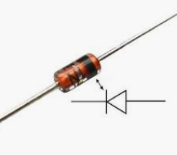

A diode allows the current to flow only in one direction, which should always flow from anode to cathode.

**2) Transistor BC548**

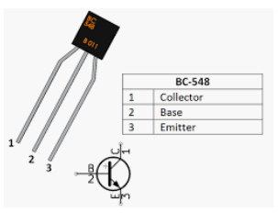

It is an npn transistor, hence the collector and emitter will be left open and the base will be put to ground and hence will be closed.

**3) Switch**

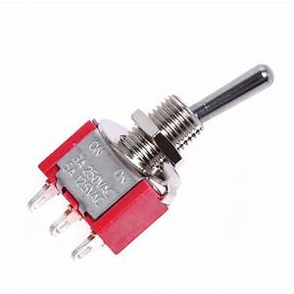

The switch is used to perform ON/OFF operation in the circuit. It is a single pole double throw type switch

**4) IC-LM3915:**

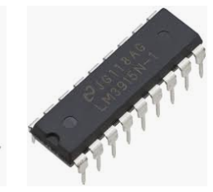

It is an integrated circuit which checks the voltage levels and drives the LES’s.

**5) Zener Diode**



It is a pn junction diode which conducts in the reverse biased condition

**5) Piezo Buzzer**

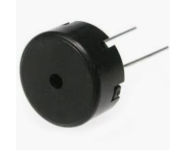

It is a device which is used to make a beep sound.

It is a low cost device and easy for the construction purpose, it has several applications as well.

**5) Variable Resistors**

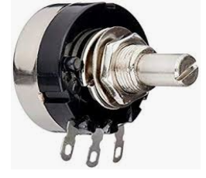

It is a three terminal resistor also known as a potentiometer or rheostat

**6) Wires**

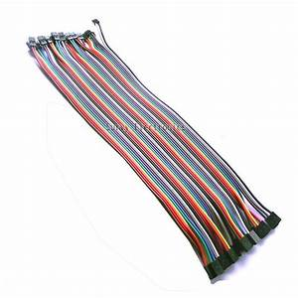

They are used for the performing the connections on the bread board.

6. CONSTRUCTION:

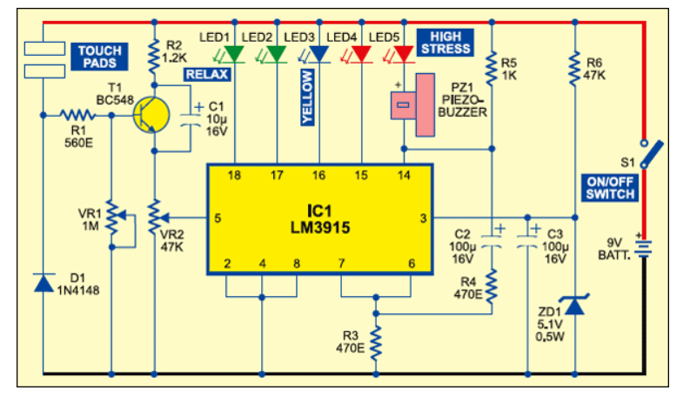

7. WORKING:

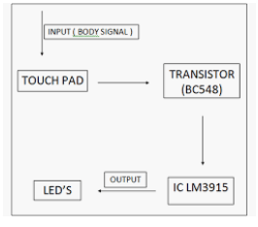

The stress meter gives you a chance to get to your enthusiastic agony. On the off chance that the pressure is high, it gives visual sign through a light emanating diode (LED) show alongside a notice blare.

The device depends on the rule that the opposition of the skin fluctuates as per our enthusiastic states. In the event that the anxiety is high the skin offers less obstruction, and if the body is loosened up the skin opposition is high. The low opposition of the skin because of increment in blood supply to the skin. This builds the penetrability of the skin and consequently the conductivity for electric flow.

This property of the skin is utilized here to gauge the feeling of anxiety. The touch stack of the pressure meter sense the voltage varieties over the touch cushions and pass on the equivalent to the circuit. The circuit is extremely delicate and identifies even moment voltage varieties over the touch cushions.

The circuit comprises of sign speaker and simple presentation segments which contains LEDs. Voltage varieties from the touch cushions are intensified by transistor BC 548(T1), which is designed as normal producer intensifier. The base of T1 is associated with one of the touch cushions through resistor R1 and to the ground rail through potentiometer VR1. By changing VR1, the affectability of T1 can be acclimated to the ideal level. Diode D1 keeps up appropriate biasing of T1 and capacitor C1 keeps the voltage from the producer of T1 relentless.

The intensified sign from transistor T1 is given to the contribution of IC-LM3915 (IC1) through VR2. IC-LM3915 is an incorporated circuit that detects simple voltage level sat its stick 5 and presentations them through LED's providing a logarithmic simple showcase. It can drive up to ten LED's individually in the speck/bar mode for every addition of 125mv in the info.

Resistors R4 and R5 and capacitors C2 from the blazing components. Resistors R3 keeps up the LED current at around 20ma. Capacitor C3 ought to be set near stick 3 for legitimate working of the IC. Zener diode ZC1 in arrangement with resistor R6 gives managed 5V to the circuit.

The circuit can be collected on a little bit of bread board. Utilize straightforward 3mm LED's and a little piezo signal for various media signs. Two self-locking ties can be utilized to tie the unit aroun

d your wrist.

Subsequent to tying it around the wrist (with contact cushions in contact with the skin), gradually shift VR1 until LED1 sparkles (expecting that you are in a casual state). Change VR2 if the affectability of IC1 is high. The contraption is currently prepared for use.

High pressure is because of the expansion in blood supply in the body. This pressure meter encourages us to get to our passionate torment if the pressure is high it gives us the visual sign through the light emanating diodes. The touch cushions in the pressure meter sense the voltage varieties and send it to the circuit. This circuit is extremely delicate and recognizes the moment varieties in the circuit. The circuit can be actualized either on breadboard or on the printed circuit board (PCB). The circuit can be developed on printed circuit board (PCB) by the procedure called welding.

8) MERITS, DEMERITS AND APPLICATIONS:

This device is chosen and used for the following reasons:

* It is Portable. The gadget is small enough to be worn around the wrist.
* Low power consumption.
* Low cost.
* Highly sensitive to small currents.
* Simply circuitry.
* Easy to use.
* Desired output.

The demerits are that

* The device has less accuracy
* The output is not measurable

APPLICATIONS

Stress meter is used:

1. For measuring resistance of skin.
2. To know the stress of the person.
3. To know mental state of person.
4. In diagnosis of excessive sweating.

Using the stress meter the person’s muscle tension changes can be seen (with the stress level which is applied on the muscle). The mental state of a person can be known using the stress meter which is based on the changes in skin resistance. It can be used as a lie detector because when a person is lying his or her stress level increases so it can be detect using the stress meter. It can also be used in physical fitness programs and the circuit is absolutely free from ambient light. It is a economical and also a low budget project. The circuit is not that complex and the components are easily available in the market.

9) FUTURE SCOPE OF THE PROJECT:

Stress meter can be further developed to design equipment like lie detectors, skin response meters, fitness meters, grip scopes etc. Therefore this model, if further developed can be used in medical field, forensic department and it even helps in improving the body fitness. The model is very useful for humans where they can control their emotional pain and the stress caused due to work load and other tensions.

10) SUMMARY:

In this project the stress of a person can be determined by sensing the skin resistance. The touch pads are used to sense the skin, skin resistance changes with the emotional state of the body, the LED’s glow accordingly. Hence the stress levels can be determined by checking which one of the LED glows. It is a very simple process and can be used as a lie detector, skin response meter etc.

11) References:

The following data for the project has been gathered from a number of sources. A list of few of the sources is:

* Electronic For You magazine
* Wikipedia.com
* Google.com
* Electrical textbooks
* Journals on stress meter